**Dot report Guidelines**

Log in DSS --> Role as PM-->ISMS tab-->Details of the team--> Select confirm if all the details are correct or select discrepancy if there is any mistake in the information provided-->Submit.

All the details in the table can be verified and notified if there is any discrepancy.

*Discrepancy could be in the Resource name, Resource code/emp id, project name, Manager name,Remote desktop .

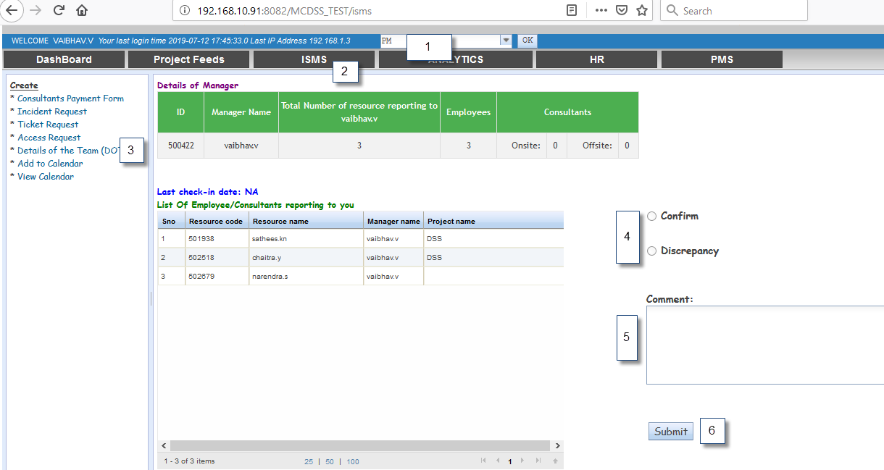

* Please ensure that you complete this within 20th of a calendar month .
* Please select the check box "See all Employees" to verify the details of the entire hierarchy.

**Points to note:**

* In case you fail to update the Dot report continuously for 2 months, an incident will be assigned to you and you have to follow the incident addressing process.
* Whenever you mark a discrepancy in the data provided, then an incident will be assigned to HR with the details of the discrepancy, so that HR department rectifies the same.
* In case of a discrepancy with the remote desktop, IDRG head would reassign the Incident to Sysop .
* Details of an Ex-Employee(s) will be available in dot until the F&F settlement is completed. The same row is highlighted in a different color.